Based on the initial analysis of the various CBC measurements, various “predictors” were ignored based on their no effect (all values were 0) or their correlation to other quantities in the set of measurements. For the prediction using classificationLearner (MATLAB**®** 2015a), the outcomes were quantified using 4 cases-TNT values, binary outcome based on the TNT value falling above or below a threshold value (suggesting a heart attack/or not) and the same cases for HsTNT.

The threshold value for TNT was chosen as 100, while that for HsTNT was chosen to be 36 for male and 15 for female patients (based on uptodate.com). The outcome was chosen based on the maximum TNT measurement for the patients (over multiple repeat measurements for the same patient), while the predictor was transformed by taking the difference between the maximum and minimum measurement for the various CBC measurements.

$Y_{k}=max⁡({TNT}_{i,k})$, $i∈no. of measurements for a patient;k∈patients$

$X_{k}=max⁡({CBC}_{i,k})$- $min⁡({CBC}_{i,k})$, $i∈no. of measurements for a patient;k∈patients$

After plotting all combinations of the measurements, the shortlisted set of CBC measurements included

|  |  |  |  |  |  |  |
| --- | --- | --- | --- | --- | --- | --- |
| 1. WBC | 6. MON | 11. pMON | 16. MCV | 21. PLT | 26. pHPO | 31. CD61 |
| 2. WVF | 7. EOS | 12. pEOS | 17. RDW | 22. MPV | 27. HDW | 32.61Sml |
| 3. NEU | 8. BAS | 13. pBAS | 18. pMAC | 23. RETC | 28. MCVr | 33. 61Lrg |
| 4. IG | 9. pNEU | 14. pNRBC | 19. MCH | 24. pRETC | 29. CHCr | 34.61_o |
| 5. LYM | 10. pIG | 15. RBCi | 20. MCHC | 25. IRF | 30. prP | 35. Gender |

Using the max(TNT) as the “response”, various algorithms were implemented on the dataset to asses the predictability. For the classification tree (<http://www.mathworks.com/help/stats/classificationtree-class.html>).

Same approach was utilized for the binary variable based on the value of the TNT

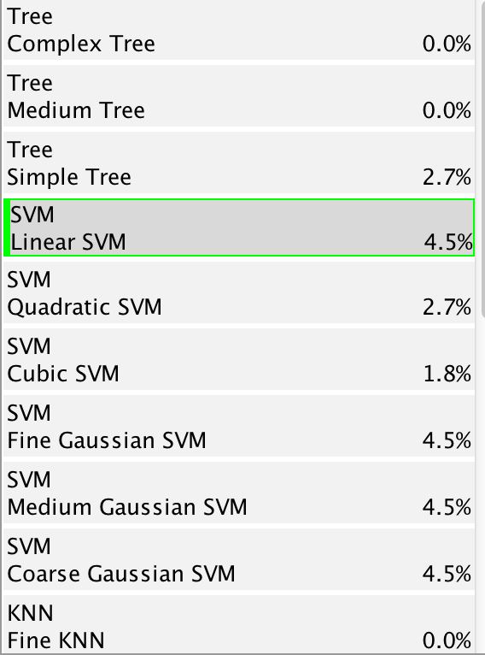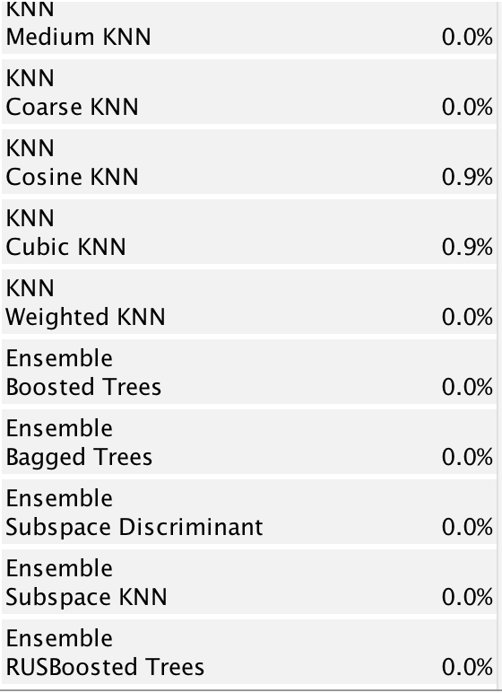

Predictions based on TNT values

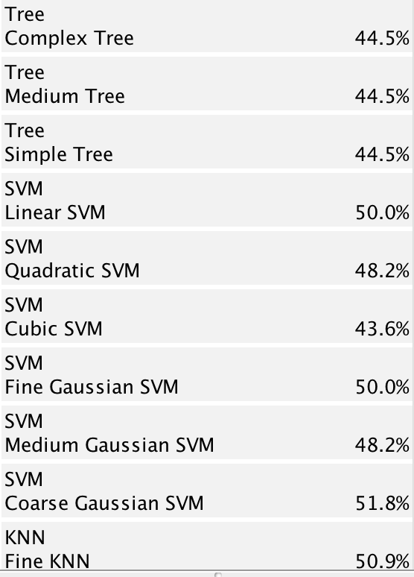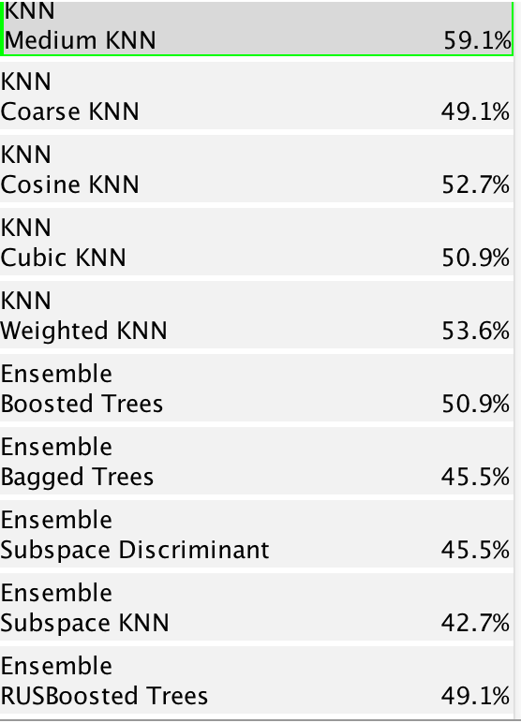

Predictions of binary outcome based on TNT values

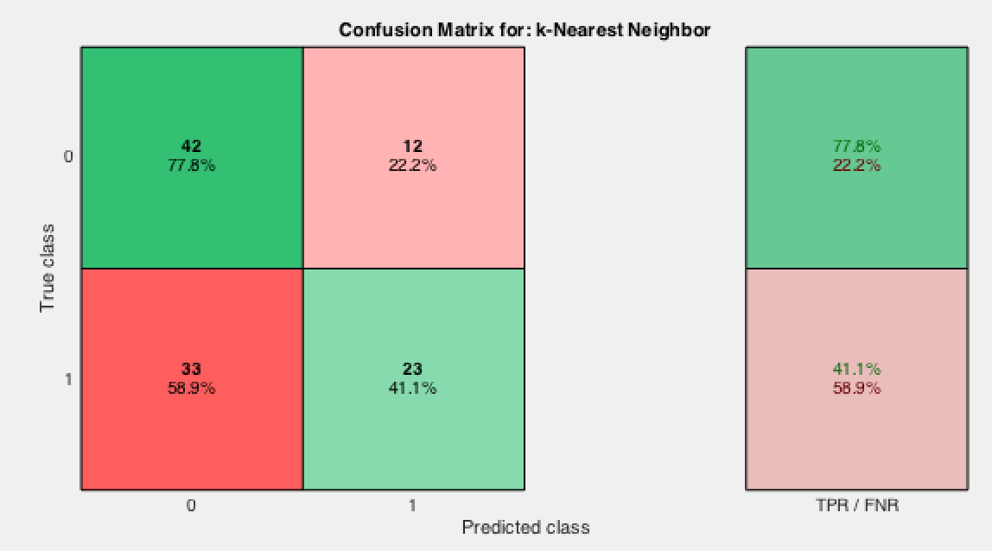

For the HsTNT values, all the algorithms had 0% predictability, except for the SVMs which had a 5.3% predictive ability.

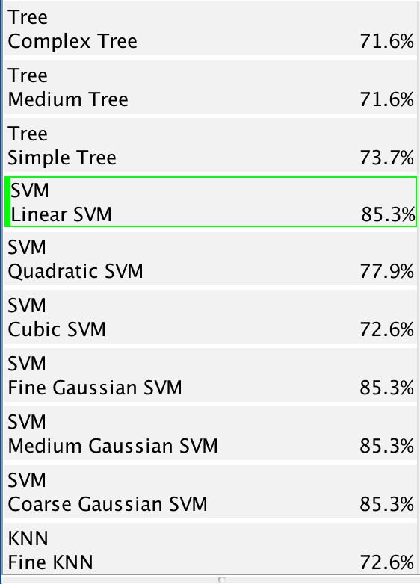 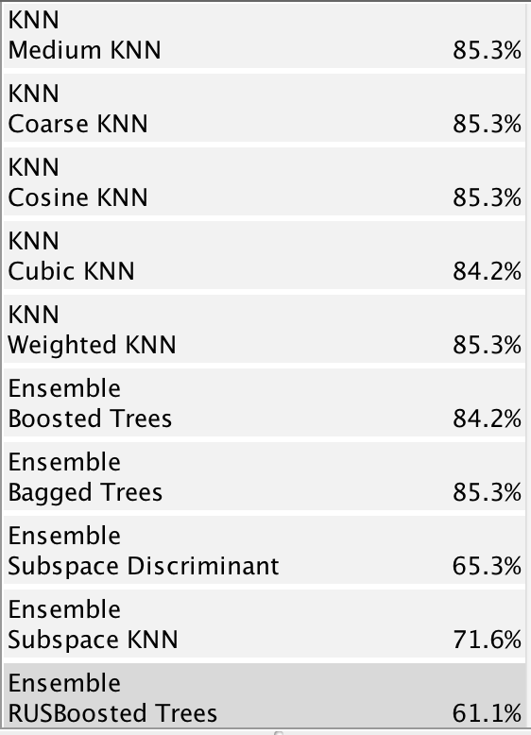

Predictions for binary outcome based on HsTNT

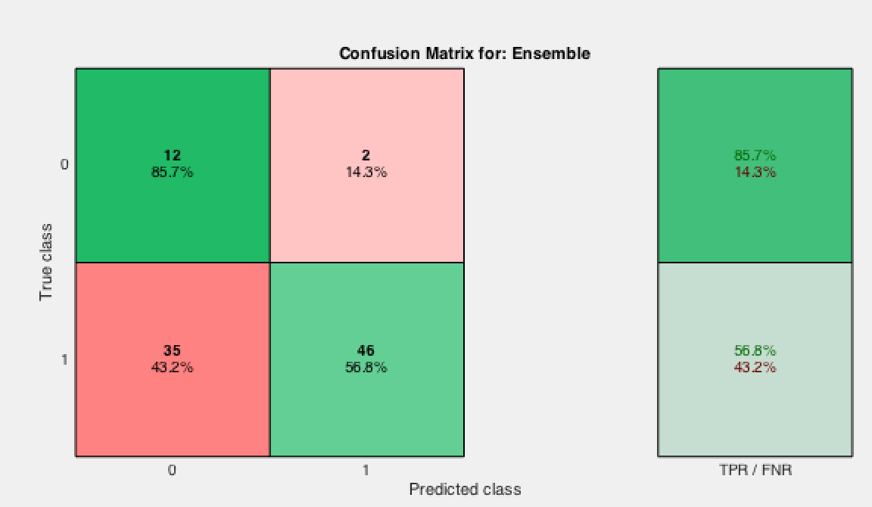

Confusion matrix using the RUSBoosted Trees for HsTNT binary outcomes

For the predictions using binary outcome for the HsTNT values, the SVM’s gave the highest prediction accuracy. However, the flaw with those predictions reflected no predictions for the “0” outcome. The overall occurrence of “0” outcomes in this dataset is rather few, thus incorrect predictions of all “0” outcomes also reflects a high overall predictive ability of the model.

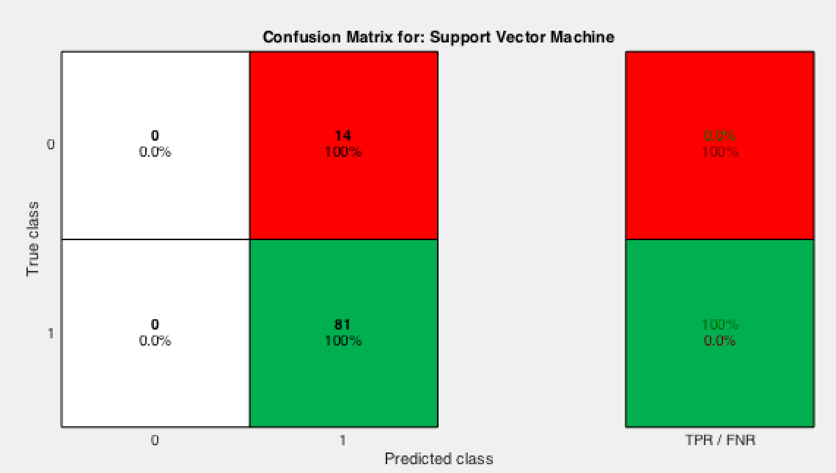

Confusion matrix using the Linear SVM for HsTNT binary outcomes

All the models were run using five-fold crossvalidation. This means, the model divides the entire dataset into 5 almost equal sized subsets, where the algorithm trains the model on 4 sets and tests it on the remaining subset. This procedure is repeated for each of the 5 subsets and finally the overall predictive ability of the model is obtained by averaging the test error over all “folds”.

Supporting figures



Correlation between predictors 1:10X1:10



Correlation between 1:10-11:20



Correlation between 1:10-21:30



Correlation between 1:10-31:40



Correlation between 1:10-41:50



Correlation between 1:10-51:57



Correlation between 11:20-11:20



Correlation between 11:20-21:30



Correlation between 11:20-31:40



Correlation between 11:20-40:50



Correlation between 11:20-51:57



Correlation between 21:30-21:30



Correlation between 21:30-31:40



Correlation between 21:30-41:50



Correlation between 21:30-51:57



Correlation between 31:40-31:40



Correlation between 31:40-41:50



Correlation between 31:40-51:57



Correlation between 41:50-41:50



Correlation between 41:50-51:57



Correlation between 51:57-51:57